

Account login

nt

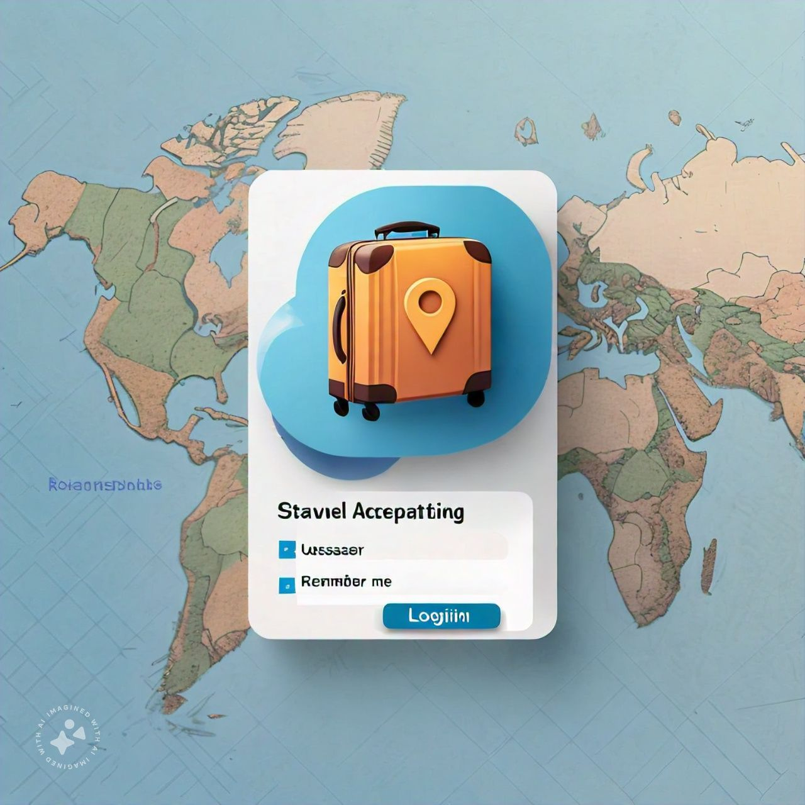

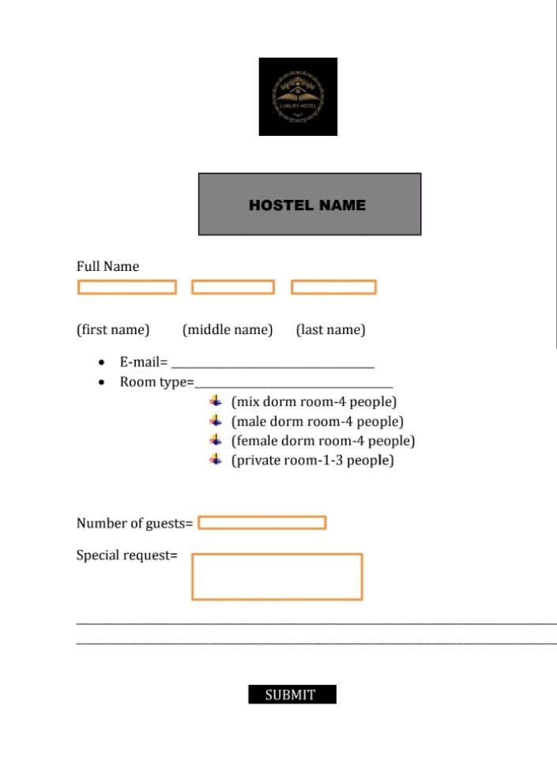



select location





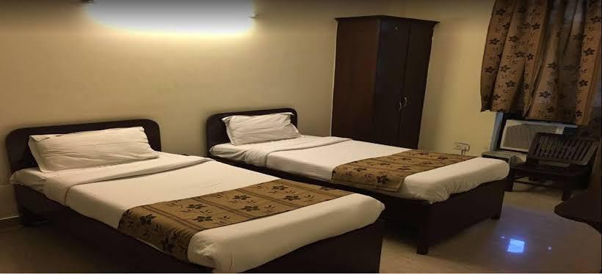



Key features

* User friendly search interface Advanced filtering option (price location,amenities,etc)
* High-quality image and virtual tours
* Real-time avalibality and booking
* User reviews and ratings

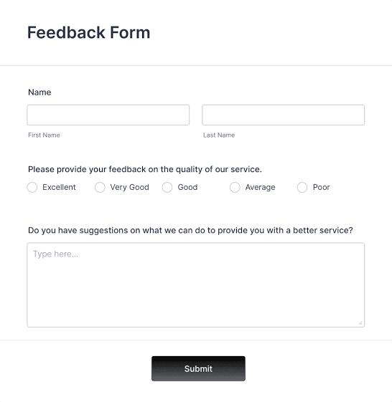

Here is an executive summary snapshot for a Stay Finder App:

App Name: Stay Finder

Tagline: "Find Your Perfect Stay, Everywhere"

Executive Summary:

Stay Finder is a mobile app designed to revolutionize the way students find and book accommodations. Our platform connects students with verified and affordable room options, making the search process easy, efficient, and stress-free.

Key Features:

- User-friendly interface for easy searching and booking

- Verified listings from trusted landlords and property managers

- Advanced filtering options for personalized results

- Secure payment processing and customer support

- Reviews and ratings from previous tenants

Benefits:

- Saves time and effort in finding the perfect stay

- Offers a wide range of affordable and verified options

- Provides a secure and trusted booking experience

- Enhances student experience and satisfaction

Target Audience:

- Students seeking accommodations for academic purposes

- Educational institutions and universities

- Landlords and property managers

Marketing Strategy:

- Social media campaigns targeting students

- Partnerships with educational institutions

- Influencer marketing and referrals

Revenue Model:

- Commission-based booking fees

- Advertising revenue from relevant partners

Competitive Advantage:

- User-centric design and verified listings

- Advanced search functionality and personalized results

- Secure payment processing and customer support

Traction:

- [Number] of registered users and listings

- [Number] of successful bookings and testimonials

Future Plans:

- Expand to new markets and regions

- Integrate additional features and services

- Enhance user experience and customer support

This snapshot provides a brief overview of the Stay Finder App, highlighting its key features, benefits, target audience, marketing strategy, revenue model, competitive advantage, traction, and future plans.